Advancements in Blood Gas Analyzers
Published on September 1, 2016

Recent product advances in blood gas analyzers and sensors can enable clinicians to direct therapy and improve patient outcomes.

By Cassandra Perez
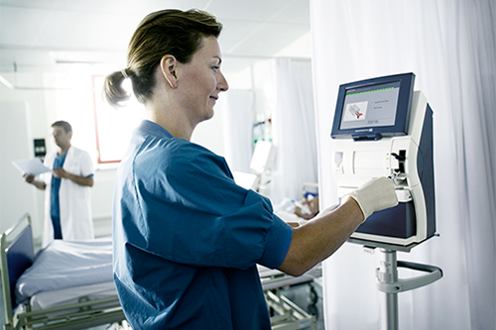
Blood gas analysis has been established as a powerful diagnostic tool in critical care and can be an important diagnostic procedure in pre-hospital and in-hospital emergency therapy.¹ The devices currently available offer a wide range of functions, but the basic parameters measured are pO₂, pCO₂, and pH, and these parameters enable the emergency physician to detect a broad range of life-threatening respiratory disturbances and acid-base imbalances.¹ The early and exact diagnosis of these conditions in the field, as well as in the emergency department, allows for efficient, properly directed therapy.¹

This article will cover recent product advances in blood gas analyzers and sensors by examining several products available on the market, and specifically explore how point-of-care testing, connectivity, and data are impacting the market and the role of clinical respiratory therapists in arterial blood gas testing.

Point-of-Care Analysis
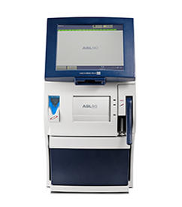
The ABL90 Flex is a blood gas analyzer from Radiometer America Inc, that is designed to provide laboratory quality blood gas results at the point-of-care for 17 parameters, including blood gas, oximetry, and electrolytes. According to Nathan Dacuycuy, product manager at Radiometer America, Inc, this device can perform 17 tests in 35 seconds using 65 µL of blood at the patient’s bedside and features an onboard sample mixer for use with Radiometer’s safePICO syringes, which standardizes mixing to minimize pre-analytical errors.

With this device’s Automatic Quality Management (AQM) system, the ABL90 Flex does not require an IQCP and is fully compliant with the definition of external control materials as established by the Clinical Laboratory Improvement Amendments.

The ABL90 Flex includes a number of features designed to improve connectivity for clinicians, including Aqure (Radiometer’s proprietary IT connectivity system), RALS, and Telcor. “Data can automatically be transmitted to and from the analyzer to many downstream systems, including EMR/EHR systems,” explains Dacuycuy. “Alternatively, with Aqure, information can be linked for positive patient identification from blood sampling using a safePICO syringe at the bedside, including auto upload to appropriate systems.”

The test results from the ABL90 Flex are made available at the point-of-care by the company because of the miniaturizing of their larger analyzer and simplifying the process and maintenance associated with the device. “We are constantly working on advancements in our blood gas analyzers, which include new parameters and systems to improve workflow,” says Dacuycuy.

Critical Care Testing
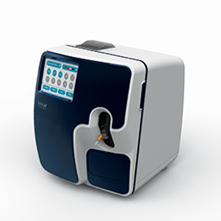
The Stat Profile Prime from Nova Biomedical, launched globally in 2013, is a blood gas analyzer designed for critical care testing and is intended to provide actionable, lab-quality results in 60 seconds. According to Brad Bullen, BS, RCP, sales product line manager at Nova Biomedical, the Stat Profile Prime has established a strong reputation of high uptime and operational time, durability, high value, and zero maintenance, and is EP-23a compliant. The device eliminates any additional workload for the clinicians to manage external QC and/or an IQCP, and the Stat Profile Prime enables back-to-back sampling following the delivery of results with no prolonged wash/rinse and calibration cycle.

The Stat Profile Prime utilizes a unique component cartridge technology, which separates the MicroSensors from the calibrator cartridge and on-board external quality control cartridge. “Primes new micro-sensor component cartridge technology results in a smaller, lighter, more powerful and less expensive blood gas/critical care analyzer,” explains Bullen. “Each cartridge offers various volume options to maximize value and minimize waste associated with older single cartridge systems.”

Overall, Nova Biomedical strives to offer multiple options of connectivity and data transmission for healthcare providers, including NovaNet, a connectivity solution for all critical care instrumentation from Nova Biomedical. NovaNet provides all of the remote review and data management solutions required by hospitals and are offered at no charge to Nova customers, according to Bullen. In addition, the open architecture available across the company’s critical care diagnostic analyzers allows for a direct connection to all middleware providers and EMR/EHR (electronic medical record/electronic health record) systems.

Nova Biomedical has several products in various stages of development, Bullen says, and the manufacturer anticipates the development of several new technologies in the future. “The quality of the result and patient care is the primary concern. We as respiratory therapists need to work in conjunction with the lab to understand the regulatory environment while we advocate the needs of the clinician,” says Bullen. “It is the role of diagnostic companies to interpret these trends and provide an analyzer that minimizes the work load for either the core lab or respiratory care.

Wireless System for Patient Testing
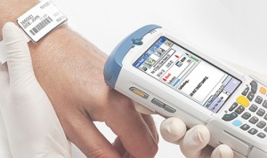
The epoc Blood Analysis System by Alere is a wireless solution for the testing of electrolytes, blood gas, and metabolites. According to Joe Baugh, MBA, MT (ASCP), senior product manager of epoc, at Alere, the device delivers accurate results at the patient’s bedside in about 30 seconds after sample introduction. To enhance connectivity, the wireless system includes both Wi-Fi and Bluetooth integration. In addition, Alere has interfaced into most widely used EMRs throughout the world.

Baugh says, “The wireless connectivity ensures that information is transferred as fast as possible, which means it is available when the provider needs it. Additional features such as barcoded cards with lot and expiry information helps the Laboratory and Point-of-Care Coordinator maintain compliance with all regulatory bodies.”

The epoc Blood Analysis System also features Smartcard technology, which aims to provide clinical, operational, and economic benefits to healthcare providers as well as a better experience for patients. The epoc Test Card offers 11 tests from a very small sample of blood (92 µL, about a 1/10th of a CC, sample), Baugh explains, and the card also offers room temperature storage for simplified inventory management. “Furthermore, each card is barcoded with lot and expiration for error-free test panel recognition. Arterial, venous, or capillary whole blood samples are all choices of sample types,” Baugh said.

“Many of the more routine tests and/or critical, stat blood testing have moved to the patient side. Much like mobile has changed the expectations for doing common tasks such as banking…bedside testing technology such as the epoc has absolutely changed clinicians expectations of the time it takes to get critical laboratory results for patients in distress,” Baugh says. “Our research & development is constantly at work on new projects to improve and/or add features that will ultimately benefit both the patient and the providers. “

Healthcare Solutions for the Future

With technological advancements and the increasing need for rapid testing and results, future trends in blood gas analyzers and systems are sure to improve patient outcomes and help healthcare professionals provide prompt treatment. “Blood gas analysis is more than just the analyzer. The entire process is important. This includes the syringes that are used and the connectivity systems that are employed to route data and manage the analyzers, simplifying the lives of the respiratory manager responsible for the CLIA license,” says Radiometer America’s Dacuycuy. “We expect new parameters to expand the use of blood gas analyzers. We also expect a greater migration from the core laboratory to the point of care with systems to help improve workflow.”

“All respiratory care departments are being asked to do more with less. The expectation is that technology and more specifically in this case blood gas analyzers will be self-monitoring and require little intervention from respiratory/laboratory staff,” according to Nova Biomedical’s Bullen. “Providing lab accurate diagnostics at the point-of-care with little to zero hands on time is the goal. The next generation instruments in development now are, or should be, incorporating these important automated functionalities.”

Future methods of testing may also improve the delivery of results as well as how tests are conducted. “In my opinion, the traditional method of taking a blood sample away from a patient and going somewhere else to process it will draw to a close. It will take some time but…that model is outdated for critical blood testing,” Baugh said. “Additionally, the newer generation of providers isn’t going to be as willing to wait on test results. They have grown up in an era where things happen instantaneously and this will continue in all aspects of our lives including healthcare.”

The development of analyzer technology and the advancement of sensor manufacturing have brought analyzers and blood gas testing closer and closer to the patient, and respiratory therapists play a critical role on the patient care team with blood analysis at its core, according to Bullen.

“Taking ownership of or playing a key role in critical care diagnostics is imperative to maintaining that key role. There is not a department better suited to provide blood gas analysis and insight into a patients cardiopulmonary function than the respiratory care department,” says Bullen. “A partnership between commercial and clinical will ensure the development of equipment and instrumentation to better meet the needs of the clinician and the patient now and in the future.” RT

Cassandra Perez is associate editor of RT. For further information, contact RTmagazine@allied360.com.

Reference
Gemes, Geza, MD, Gernot Wildner, MD, and Gerhard Prause, MD. “Arterial Blood Gas Analysis: Use of Point-of-Care-testing in the Field.” RT, The Journal for Respiratory Care Practitioners, Dec. 2004. Web. 15 Sept. 2016.

