Advancements in Endotracheal Tube Holders
Published on August 15, 2016

Recent product advances in holders for the stabilization of adult and pediatric endotracheal tubes and tracheostomy tubes allow healthcare providers to minimize complications and maximize patient comfort.

By Cassandra Perez

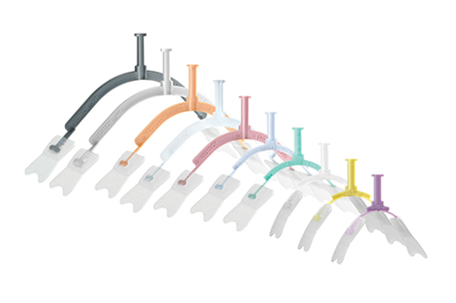
Endotracheal tube (ETT) intubation is a medical procedure in which a tube is placed into the trachea through the mouth or nose for airway maintenance or ventilatory support, and the ability to secure a patient’s airway is essential in the management of severe illness and injury. For ease of adjustment, placement, and tube removal, an endotracheal (ET) tube holder can be a valuable tool for the medical professional to successfully perform this procedure, minimize harm, and maximize patient comfort.

This article will cover recent product advances in holders for the stabilization of adult and pediatric endotracheal tubes and tracheostomy tubes, and specifically examine how these devices are preventing accidental extubations, skin ulcers, and other complications, as well as facilitating oral care.

Stabilization Device

A significant feature of an endotracheal tube holder is stabilization, and this component can help secure the tube place after insertion. According to Stu Novitz, vice president of sales and marketing, and Kevin Johnson RRT-NPS, clinical consultant, for B&B Medical Technologies, “Endotracheal tube intubation (ETT) is a delicate, invasive, medical procedure. Once the ETT is placed in the patient’s airway it is important to have a reliable ETT securing device at hand to assure that the tube remains secure, does not migrate, and prevents accidental extubation.” As such, B&B Medical Technologies offers the StabilTube, a patented endotracheal tube holder designed to eliminate repetitive taping and is also intended for use as a stabilization device.
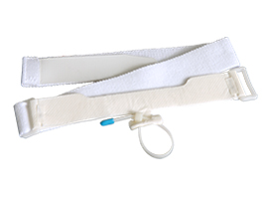
The StabilTube is comprised of hypoallergenic materials and includes a variety of features to minimize skin-related problems, including an adjustable Velcro strap that can lessen the incidence of skin breakdown and a protective skin wipe that forms a topical barrier between the skin and adhesive for additional protection against skin breakdown and irritation, Johnson and Novitz explain. For easy adjustment, this product includes a resealable cable tie that secures the ETT to the StabilTube, which can be adjusted to reposition the endotracheal tube when needed.

The product, available for child and adult application, can accommodate patients from 40 to 300 pounds with neck sizes up to 26 inches. Also, the StabilTube can be used for endotracheal tubes 4 mm and greater. Overall, Johnson and Novitz say, “StabilTube ensures ET tube stability and minimizes the incidence of inadvertent extubations.”

Neonatal Tube Fixation

The NeoBar from Neotech Products is an ETT tube holder that includes a variety of features for securement, patient comfort, and oral care. NeoBar is designed to keep the ETT in the center of the mouth and off the palate, which can help prevent grooving to the palate and teeth buds in the gum lines, according to Marci Hodges, RNC-NIC, BSN, senior clinical specialist at Neotech Products. This product also includes the NeoBond Hydrocolloid securement tabs that allow for a secure hold to the face and enables safe securement to the patient’s skin without causing breakdown or skin damage. There is no need for additional materials, including securement or skin protectant, and the “skin friendly” tabs make removal and/or replacement more comfortable for the baby.

The secure hold provided by the Hydrocolloid tabs also allows the clinician the easily adjust the depth of the ETT, and with no tape needed around the mouth, the product aims to provide a cleaner securement. “Oral care is easy to perform with NeoBar because there is no tape secured directly at the patient’s mouth…already making it a cleaner solution free from saliva and emesis that could potentially cause infection,” Hodges says. “The mouth is easily accessible for both oral and developmental care with the platform of the NeoBar sitting midline above the mouth. Families can also easily view the baby’s face.”

Also, since chemicals not approved for neonates are not needed to help remove or secure the product, the manufacturer strives to further ensure infant safety. NeoBar is available in a number of sizes for proper fitting, and the product is designed to prevent accidental extubation in several ways. NeoBar eliminates the need to move the ETT side to side in the mouth, which can prevent palate and/or gum trauma, and the ETT is securely held on the platform to make it easier to visualize where the ETT is secured.
Hodges says, “By properly sizing and placing the NeoBar, there will be less ‘play’ in the ETT once secured to the NeoBar, unlike tape that will constantly move with the cheeks depending on the position of the baby because of where it is secured.”

Adjustable Tube Holder
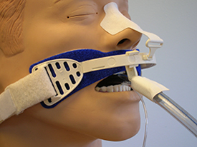
The new 330 Adjustable Adult ET Tube Holder from Marpac features a non-adhesive material for skin comfort. “During longer intubations, oral care and pressure ulcers are a common concern. Being able to easily relocate the tube laterally benefits first and foremost the patient, but also the care facility and staff,” according to Dave Mayberry, product designer for Marpac. “The 330 utilizes a proprietary non-adhesive material on the main portion of the product where it touches the patient’s skin. Soft and breathable, its grip on skin is quite unique.” The new 330 also utilizes a skin-friendly adhesive strip that is placed on the nose of the patient, and the point of attachment is designed to provide a more secure fit and keep the device securely in the correct position, Mayberry explains.

Additionally, the new 330 Adjustable Adult ET Tube Holder can be packaged with the Marpac’s 910 NG Wrap. Mayberry says, “This device allows a quickly adjustable and very secure method to keep the NG tube with the ET tube. Anyone from any department can make these adjustments with confidence.”

Tube Fastener
The AnchorFast oral endotracheal tube fastener, manufactured by Hollister, is a fastener that is designed to provide a convenient means to hold an endotracheal tube securely in place without the use of adhesive tape. Patrick Noble, general manager of continence care & critical care, US, for Hollister, says, “The oral endotracheal tube fastener allows repositioning of the tube in either direction along the track without removal of the device.” This ET tube fastener contains skin barrier pads that fasten the device in place, and the special pad formulation is intended to be gentle on the skin, moisture resistant, and easy to apply.
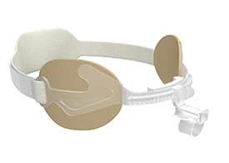
For added security, the AnchorFast includes an ET tube wrap with a one-click security clamp that locks the ET Tube in place, and one click releases the clamp for ease of tube repositioning. In addition, this product features an adjustable neck wrap as well as a gliding tube shuttle that allows for easy side-to-side repositioning of the ET tube for improved oral care. “Clinical benefits of the AnchorFast oral endotracheal tube fastener include easy access to the oral cavity to optimize oral care and helps prevent formation of lip ulcers as part of a multifaceted approach,” says Noble.

Overall, Hollister considers customer feedback a significant part of the development process for their products. According to Noble, “Hollister supports ongoing innovation driven by customer feedback. Innovation happens when we listen to the people who use our products. What they say matters to us.”
Innovations for Patient Safety

Advancements in medical technology enable healthcare providers to better diagnose and treat patients in order to achieve more successful outcomes. The unique developments made in endotracheal tube holders allow medical professionals to minimize complications and harm as well as improve patient results. For example, B&B Medical Technologies is investigating the use of advanced adhesives for its ET securing devices, according to Novitz. Overall, clinicians depend on the superior performance and quality of these products to improve patient care, and with manufacturers continually making upgrades and innovations to ET tube holders, the success of this delicate medical procedure will continue to improve for the betterment of patient health. RT

Cassandra Perez is associate editor of RT. For further information, contact RTmagazine@allied360.com

