

Date
Address Block
Address Block
Address Block

Dear_______________,

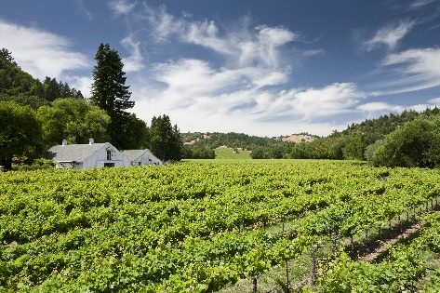
I’ve had the pleasure of making Pinot Noir and Pinot Gris in Sonoma County for more than a decade and am always inspired by the beautiful surroundings of our namesake MacMurray Estate in the Russian River Valley. With the philosophy that great wines reflect their origins, I consistently try to make wines showcasing the nuanced flavors of each vineyard and then blend them together to create a delicious combination of tastes and textures. With a unique combination of soil, climate and sun exposure, each vineyard delivers distinctive characteristics that give me a lot to work with.

At MacMurray, we are lucky enough to have vineyards in the Central Coast and the Russian River Valley, which are some of California’s most sought-after Pinot Noir regions. With incredible grapes as our foundation, we dedicate ourselves to crafting the finest of Pinot Noirs. We own every step of the winemaking process, from rootstock selection to pruning, harvesting to blending and barrel selection. We focus on the whole process by being the grower and the winery, which is a luxury in the wine business. The results are great wines that we are proud to share.

I am pleased to share two wines with you: our 2016 Russian River Valley Pinot Gris ($20 SRP) and 2016 Central Coast Pinot Noir ($23 SRP). The Russian River Valley Pinot Gris is made from the MacMurray Estate homestead, as well as from another estate-owned vineyard named Two Rock. Each of these vineyards imparts rich fruit flavors and highlights the unique attributes of each place. The Central Coast Pinot Noir is made primarily with grapes from our Olson Ranch Vineyard, a spectacular vineyard in the Santa Lucia Highlands known for producing elegant Pinot Noir.
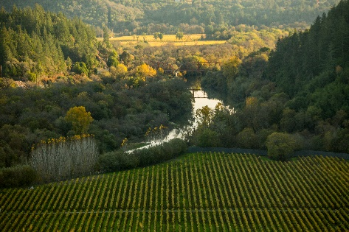
The 2016 harvest brought us exceptional quality grapes in both regions. The steady growing season in the Russian River AVA began with some welcome winter rain and warm temperatures in spring. The mild weather in late summer allowed the grapes to ripen evenly and develop balance between acidity and flavors. The entire ripening season had cooler than average daytime highs and cool nights, which were the perfect conditions for growing grapes that retain delicate aromas and flavors.

The growing season in the Central Coast delivered high quality grapes in a season that also brought winter rainfall and warm spring temperatures. Summer arrived early in 2016 and the cool nights and daytime warmth in July and August allowed the grapes to mature quickly, giving us small berries in excellent condition. This stellar vintage allowed us to make wine with outstanding color, intensity and an optimal balance.

These elements came together to create wines that are beautiful expressions of their vineyards and of the dedication of the women and men that make them. Our Russian River Pinot Gris offers notes of white peach, ginger and dried fig with a refreshing acidity. The Central Coast Pinot Noir is an opulent wine with flavors of red fruit and distinct notes of spice and vanilla. The most exciting reward for me as a winemaker is to have people enjoy our wines and experience a taste of these special regions in each glass. I am honored to have you share them with family and friends.

Warm Regards,



Boyd Morrison
Winemaker, MacMurray Estate Vineyards



MacMurray Estate Vineyards® 2016 Russian River Valley Pinot Gris

With estate vineyards in some of the world’s most sought-after wine regions, MacMurray Estate Vineyards crafts an award-winning collection of Pinot Noir and cool-climate white wines from Sonoma County and the Central Coast. Our winemaker oversees everything from rootstock selection to barrel aging, to create a portfolio of wines that illuminates the unique, nuanced flavors of each estate vineyard.

About the Wine:
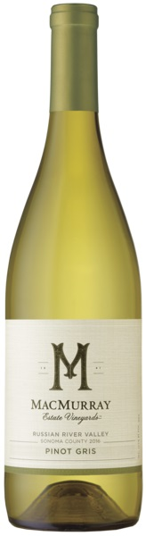
Our MacMurray Estate Vineyards Russian River Valley Pinot Gris boasts expressive, perfumed aromas and layers of white flowers, Asian pear and baked apple. Refreshing acidity appears on the palate, complemented by signature white peach, ginger and dried fig notes. The lingering finish is polished by satin-like texture in a wine that will enhance with age.

About the Vineyards:
This Pinot Gris was primarily crafted from two of our estate vineyards in the Russian River Valley AVA, where maritime influences usher fog through the river valley to cool the vineyards each day.

MacMurray Ranch Vineyard: Our namesake vineyard is home to Pinot Noir and Pinot Gris vines, grown in well-drained loam soils. The lower valley is cool and foggy, while the upper valley basks in the sun. The Pinot Gris fruit on our Monte Bianco block, gave this blend its decadent notes of apple and baked spice.

Two Rock Vineyard: A cool, foggy climate, matched by sandy loam and gravelly clay loam soils, makes this vineyard ideal for growing cool-climate varieties. Blocks Y03 and Y04 on Two Rock Vineyard, which sees heavy fog intrusion and strong winds, gave this Pinot Gris its peach and apricot flavors and bright acidity.

Viticulture Notes:
The 2016 vintage was ideal for our Russian River Valley vineyards. Abundant rainfall throughout most of the winter helped replenish the root zones and kept soil damp into the spring. Bud break occurred as early as February, and temperatures from March through May gradually increased. The moderate weather allowed rapid growth in the vines and contributed to our early August harvest. These conditions coupled with constant coastal breezes provided an interesting combination of elements to produce concentrated fruit flavors and a crisp acidity.

Winemaking Notes:
All of the grapes for our Russian River Valley Pinot Gris were harvested by hand to minimize the extraction of color from the grape skins. Each lot was fermented separately, and approximately one-third of the wine remained on its lees and was stirred every two weeks to develop a smooth and round mouthfeel. The remaining lots were racked off their lees at the end of fermentation to preserve the spicy baked apple aromas and flavors. These techniques created a complex wine with an abundance of fruit, balanced by a rich mouthfeel. To retain the fresh, natural fruit flavors of the Pinot Gris grapes, this delicate wine did not come in contact with oak.

Varietal Content: Pinot Gris
Alcohol Level: 14.5%
Titratable Acidity: 0.61g/100ml
pH: 3.24
Appellation: Russian River Valley
Harvest Dates: 8/29-9/23
Clonal Selections: 1, 3, 4, 5, 146, 152
Aging: 100% Stainless Steel



MacMurray Estate Vineyards® 2016 Central Coast Pinot Noir
With estate vineyards in some of the world’s most sought-after wine regions, MacMurray Estate Vineyards crafts an award-winning collection of Pinot Noir and cool-climate white wines from Sonoma County and the Central Coast. Our winemaker oversees everything from rootstock selection to barrel aging, to create a portfolio of wines that illuminates the unique, nuanced flavors of each estate vineyard.

About the Wine:
The MacMurray Estate Vineyards Central Coast Pinot Noir opens with its striking deep ruby color and aromas of red fruit and cinnamon. Delicate tastes of red cherry, ripe cranberry, currant and raspberry are accented with distinct spice notes, a hallmark of Olson Ranch Vineyard. Plush tannins integrate effortlessly with red fruit flavors and hints of vanilla to create a soft mouthfeel and a satisfying, long finish.
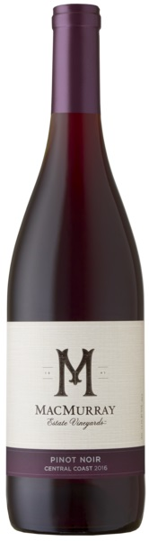
About the Vineyard:
This Pinot Noir was crafted almost entirely with fruit from our Olson Ranch, a spectacular vineyard in the Central Coast’s Santa Lucia Highlands appellation known for producing elegant, nuanced Pinot Noir.

Olson Ranch Vineyard: This phenomenal site is heavily influenced by the nearby Pacific Ocean, making this a cool and windy site characterized by clay loam soils over fractured limestone. Our Pinot Noir grapes grown here deliver classic, cool-climate Pinot flavors of red cherry and raspberry.

Viticulture Notes:
The 2016 harvest was early with a yield of exceptional quality fruit. The season began with winter rains, warm spring temperatures and an early summer. Cool nights and warm days in July and August allowed the grapes to mature perfectly, producing small berries in excellent condition. The vintage is notable for its concentrated, fruit-forward characters, fine color and balanced acidity.

Winemaking Notes:
The grapes were destemmed, but not crushed, and cold soaked for up to five days to enhance the extraction of color and flavor. We fermented in upright stainless steel tanks at a maximum temperature of 83°F using yeast selections AMH, RC212 and D254. This wine underwent malolactic fermentation and was oak aged to develop a smooth and rich mouthfeel.

Varietal Content: Pinot Noir
Appellation: Central Coast
Alcohol Level: 14.5%
Titratable Acidity: 0.57g/100ml
pH: 3.68
Harvest Dates: 9/1-10/15

