Weighing Advantages, Limitations of Temporary Oral Appliances
Published on October 12, 2016


Should these transitional appliances become a permanent part of the sleep professional’s toolkit?

By Cassandra Perez

Temporary oral appliances are mandibular advancement devices employed with patients before they receive a custom oral appliance for the treatment of obstructive sleep apnea (OSA). These devices are also sometimes referred to as “interim appliances,” “transitional appliances,” or “trial appliances.” This article will discuss their advantages and limitations by examining several products currently on the market as well as the devices’ clinical value.

Temporary Oral Appliance Advantages

Mayoor Patel, DDS, MS, owner of Atlanta’s Craniofacial Pain and Dental Sleep Center of Georgia, says the use of temporary devices can help determine if oral appliance therapy will be of any benefit to the user. That is, if the temporary device shows benefit, a custom oral appliance would then be ordered. But if the temporary device does not show a benefit, then the device served as a cost-effective way to ascertain that oral appliance therapy will not be efficacious with the given patient.

Dan Levendowski, co-founder and president of Advanced Brain Monitoring, maker of temporary oral appliance Apnea Guard, makes a similar point. He says temporary devices allow “patients and payors [to not] have to make the significant financial commitment for a custom appliance prior to determining if mandibular advancement is efficacious.”

Because Apnea Guard also helps predict the optimal jaw forward position, Levendowski says it can substantially reduce the time needed for patients to reach the most efficacious end point in their custom appliance. Apnea Guard is cleared by the FDA to be fitted by any trained healthcare professional, so a trained sleep center staff person could fit it and conduct the efficacy study prior to referring the patient to the dentist to fit the custom appliance.
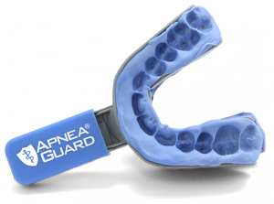
Advanced Brain Monitoring Apnea Guard

ApneaRx, a boil and bite oral appliance from Apnea Sciences Corporation, is another temporary appliance with predictive value. Patrick Maley, COO of Apnea Sciences Corporation, says, “ApneaRx can also be used as a predictor device for the more expensive custom oral appliances.” A study conducted by Dennis Hwang, MD, et al, and exhibited as a poster presentation at the 2014 American Academy of Dental Sleep Medicine (AADSM), fit 73 patients with ApneaRx. Of the 52 who returned for post-PSG, 69% were “responders” (AHI 4% improvement; post-AHI<15). Overall, AHI improved from 17.9±12.7 to 7.1±8.4 (p<0.01). In responders, there was essential normalization of AHI from 19.4±14.3 to 2.9±2.4 (p<0.01), and 24 patients were referred for custom oral appliances. The 2014 version of the poster “Feasibility Pilot Evaluating the Use of Pre-Fabricated Titratable Mandibular Advancement Device for Management of Obstructive Sleep Apnea” stated that comparison of efficacy with ApneaRx was pending; a 2015 version of the poster published on ApneaRx’s website shows that 12 of 12 patients deemed good candidates by the ApneaRx trial had significant response to a custom oral appliance, suggesting predictive value.¹
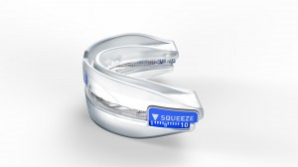
Apnea Sciences ApneaRX

Another benefit of temporary oral appliances is immediacy of treatment. For example, the EMA First Step 90 Day Trial Appliance manufactured by Myerson is a temporary custom oral appliance that allows patients to begin treatment the same day. “Many patients are unaware that oral appliances are an option to treat sleep apnea and snoring. Custom temporary appliances allow patients to begin their treatment plan the same day,” says a Myerson spokesperson. “Simple and quick in-office fabrication means the patient can leave with a custom fit EMA First Step appliance the same day and start sleeping better that night.”
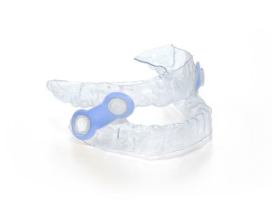
Myerson EMA First Step 90 Day Trial Appliance

In addition to allowing for immediate treatment, Jamison R. Spencer, DMD, MS, inventor and owner of temporary oral appliance Silent Sleep (also marketed as “Easy Airway” by Henry Schein and “Snorebyte” by Braebon in Canada), says some provisional devices can be used with orthodontic treatments. For example, Silent Sleep can be used over Invisalign style aligners and with traditional braces. “This allows for treatment of the OSA simultaneously with treatment of the malocclusion or aesthetic tooth movement. You typically cannot do that with a custom fabricated appliance,” Spencer says.

Silent Sleep is only adjustable by the dentist. “In many cases, this is an advantage as the dentist may not want the patient changing the position of the temporary appliance, being lost to follow-up, and having problems develop such as bite changes, tooth movement, etc,” Spencer says.
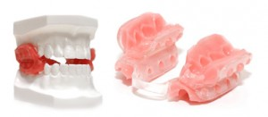
Silent Sleep

The ZQuiet S.A. from Sleeping Well, LLC, is a temporary oral appliance that is designed to treat both snoring and mild to moderate OSA. “The advantage of a temporary appliance is that it provides the clinical benefit of a custom appliance in a cost and time efficient manner. The ZQuiet S.A. is a prefabricated, non-custom mouthpiece that requires no molding or chair time,” says Daniel Webster, co-founder and vice president of Sleeping Well.
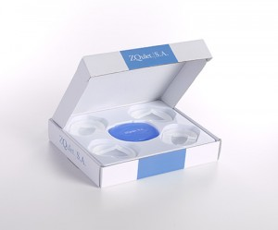
Sleeping Well ZQuiet S.A.
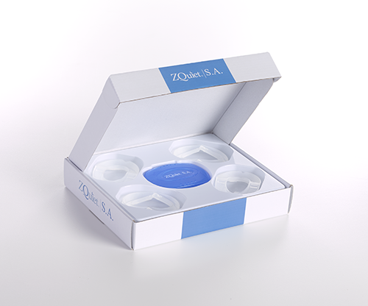

Temporary oral appliances can provide an interim solution during the period of time that a broken or damaged device is repaired or replaced, several sources say. “I like to have an adjustable temporary for certain situations, and a non-adjustable (by the patient, that is) for other situations. There are times when a temporary oral appliance is indicated, such as when a custom appliance is…lost, and the patient needs treatment while a new appliance is fabricated,” Spencer says. As such, these devices can help ensure continued patient therapy.

Limitations

As temporary oral appliances are, by definition, not designed for long-term use, they do not last as long as custom oral appliances. For example, the Apnea Guard cannot be used for more than 30 nights, and ApneaRx will last between 9 and 18 months. Webster says, “I believe that the most significant limitation of temporary appliances is longevity of the appliance. This is not a negative since the device is intended to serve as a non-permanent, interim solution.”

Patel says that, in his opinion, the life of the device is the biggest limitation. But he adds that the size of temporary oral appliances may be a drawback. Temporary oral appliances “may be bulky in nature compared to custom appliances,” he says.

In addition, there is also a possibility of side effects with the use of temporary oral appliances. Spencer says, “Temporary oral appliances can result in the same side effects as custom appliances. Proper follow-up, patient consent, and use instructions are perhaps even more critical with the use of temporary appliances.”

Finally, provisional devices may not be suited for all patients. For example, Patel says patients with poor dental condition, especially tooth mobility, may not be good candidates for temporary oral appliances.

Clinical Value of Temporary Oral Appliances

Kathleen Bennett, DDS, the immediate past president of the AADSM, says non-custom appliances have little clinical value to the patient due to a variety of factors, including fit and durability. “I don’t make them for any of my patients,” Bennett says.

Bennett cites the current clinical guidelines of the AADSM,² which state that custom fit oral appliances are recommended. “It is misleading when people buy their healthcare online or are administered a prefabricated device…because it’s not the same as what we do with a custom fitted oral appliance,” Bennett says. “You achieve a much higher level of treatment efficacy with a custom appliance.”

Due to the follow-ups required with a custom appliance and a more accurate fit, Bennett says custom appliances can improve patient outcomes when properly fitted, inserted, and adhered to by a patient. She explains that the way these custom appliances are billed, 3 months of follow-up must be included. “In my practice, we follow up with patients for 3 months. Then, when we have them organized and sleeping well, and they’re asymptomatic, then I’ll see them 6 months later, and then yearly,” says Bennett, who has limited her practice to oral appliance therapy since 2005.

Bennett says fit and measurement are two limitations of temporary devices. “Figuring out where to put the jaw is both an art and a science. For someone who does it full time, we [dentists] spend a lot of time trying to figure out where to position patients’ jaws to make sure that we get a resolution to suit them. To ask patients to randomly figure that out themselves is very difficult for patients to do,” says Bennett. Temporary appliances are “not as adjustable [and are] usually a more fixed appliance,” she says. “You will also find that, in many cases, temporary appliances hurt. They don’t fit well, so the patient has a sore tongue or stops wearing it.”

Bennett also disagrees that temporary oral appliances have any predictive value as to whether a custom oral appliance therapy will be successful. “How would you come up with a predictive value when you don’t have any tracking of how far you’ve advanced the jaw? It’s not quantitative enough,” says Bennett.

Overall, Bennett says to sleep professionals, “I’d recommend they follow the clinical guideline, which provides practice parameters for providing excellent care to your patients. Having a custom made appliance, done by a qualified dentist, will give [the patient a] higher level of care…and [will provide] a much better outcome.”
A “Permanent” Option in the Sleep Armamentarium?

The use of temporary oral appliances may become more widespread in coming years with new developments and advancements. “I feel it is important to have a couple of temporary oral appliances in your armamentarium. I believe that all dentists who are engaged in the treatment of OSA with custom fabricated oral appliances should be familiar and comfortable with the use of at least two temporary appliances,” says Spencer. “You owe it to your patients to be prepared to help them when they need it.”

Cassandra Perez is associate editor for Sleep Review. CONTACT cperez@allied360.com

References
1. Available at www.apnearx.com/wp-content/uploads/Kaiser-Poster-1-26-15.pdf. Accessed October 12, 2016.
2. Ramar K, Dort LC, Katz SG, et al. Clinical practice guideline for the treatment of obstructive sleep apnea and snoring with oral appliance therapy: an update for 2015. J Clin Sleep Med. 2015;11(7):773–827.

