Weighing PAP Interface Choices for Patients Who Shed Pounds
Published on March 2, 2017

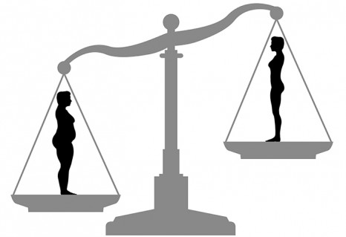
Following significant weight loss, PAP therapy users may need to adjust their mask or headgear.

By Cassandra Perez

In conjunction with positive airway pressure (PAP) therapy, patients may be advised by their healthcare providers to lose weight to help manage their obstructive sleep apnea (OSA). However, an unexpected consequence of this healthy weight loss can be changes in interface and headgear fit. As a patient’s weight changes, the PAP mask and headgear may require patient and clinician attention.

Headgear Adjustments May Be All That’s Needed

First, the good news: In some cases, simple adjustments to the existing interface are all that’s needed to regain proper fit after weight loss.

Kevin Coldren, director of product management, patient interface, at Philips Respironics, says mask sizing is predominantly based on facial characteristics that are not impacted by the patient’s weight. “These facial measurements are dependent on the underlying skeletal structure and they will not change due to weight loss,” he says. “It is possible that a mask may fit differently if a patient loses a significant amount of weight, but simply adjusting the mask should correct any discomfort or leak issues.”

Lisa Bond, RST, RPSGT, director of clinical operations and scoring services at Advanced Sleep Management, LLC, says many interfaces are fit by the distance from the bridge of the nose down, which may not vary significantly with weight loss. Additionally, with newer styles of interfaces being just over the end of the nose, Bond says weight loss may not impact the sizing; however, she says, headgear adjustments may be needed.

Daniel Lane, RPSGT, CCSH, president of the Board of Registered Polysomnographic Technologists (BRPT) board of directors, says, “Headgear fit is also important as a patient loses weight. If a mask does not fit properly, excessive leaking will reduce the set pressure, and the wearer will not benefit fully from PAP therapy.” Lane adds that if the straps are too tight, the wearer may experience discomfort and possible skin allergies.

At Home Fixes

Adjusting the existing mask on their own may be one of the simplest ways for patients to ensure proper mask fit following weight loss. “In most cases, it would be advisable to gently tighten the headgear straps to take up any slack in the mask fit,” Coldren says. “As a general rule, masks should be adjusted each night as needed to ensure a proper fit, and these frequent adjustments should be more than sufficient to accommodate gradual weight loss.” If the patient cannot achieve a proper fit, Coldren says a refit from a clinician may be the best solution.

To ensure a proper mask fit and prevent a leak, Nancy Brewer, RPSGT, clinical specialist at ResMed, recommends patients lie in bed, turn on their device at its full prescribed pressure, loosen the straps to the point of leak, and then slowly bring in the straps until the leak stops. “If the strap is overtightened in order to stop the leak, then both the seal and patient’s comfort could be jeopardized, and it might be appropriate to consider a different size,” Brewer says. “If a patient tries these steps and still has a loosely fitting mask, it might be time to try a different mask or mask size.”

Simple cleaning and replacing of equipment can also be beneficial. Brewer says, “Mask leak is often due to a cushion or headgear being too old or not properly cleaned. Replacing and cleaning mask parts will often correct a fitting problem, so I always recommend that step first.”

Coldren echoes this sentiment and says the useful life of a mask depends on the use conditions and maintenance. He recommends patients clean masks after each use, regularly inspect their masks and headgear for damage or wear, and replace components as necessary.

When Professional Help May Be Needed

Adjusting the pressure of the CPAP machine may be another option. Bond says some interfaces do not do well with higher pressures, and with weight loss the patient may find they need lower airflow.

According to Brewer, the cheeks and the sides of a patient’s nose are two areas for potential mask leak after significant weight loss. “As the patient’s facial subcutaneous fat decreases, the cheeks can become more hollow, the facial lines deeper, or the nose narrower, thus not providing enough surface for a previously fitting mask to seal,” says Brewer.

Angela Giudice, RPSGT, director of clinical sales and education for 3B Medical, says cheeks and the forehead area may change. “Unfortunately, those are areas where contact and seal of the mask are of great importance. I’ve even seen patients whose noses have shrunk significantly.”

Interface Types
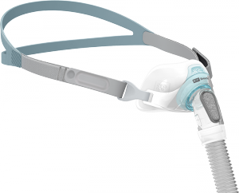
Due to minimal contact with the face, nasal pillows-style masks can be a good choice for patients who are losing weight. Shown here is the Brevida by Fisher & Paykel.
According to Lane, the most effective type of mask for patients who continue to lose weight is the nasal pillow. Lane explains, “Nasal pillows are small mushroom-shaped flexible pieces that come in pairs and fit into either nostril. The pillows in the nasal pillow mask do not rest on the patient’s nose, upper lips, or cheeks. Therefore, a loss of facial tissue doesn’t interfere with a good fit.”

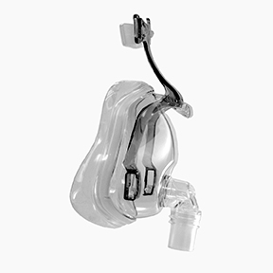
3B Medical’s Ecco masks are equipped with a sliding forehead adjustment, which is helpful for patients who need to tighten their mask’s fit after losing weight.

Giudice recommends patients try another sized cushion or new headgear that may be smaller. The Aerie and Ecco masks from 3B Medical are equipped with a sliding forehead adjustment, which adjusts on an angle and allows for a comfortable seal for a variety of facial structures and shapes, Giudice says.

The Gecko nasal pad by ResMed, a soft strip placed across the nasal bridge, can help fill in space where a mask cushion is leaking. Brewer says the pads are primarily used to cushion the nasal bridge but they can also fill in gaps at the side of the nose or chin, or around the corners or sides of the mouth.

To ensure a proper mask fit, some manufacturers offer sizing gauges to assist clinicians. According to Kelly Rudolph, president of mask maker Hans Rudolph, its gauge is reusable and will help ensure patients are fitted into the correct size. Options from Hans Rudolph include the 7600 Series Reusable Multi-Patient Use V2 CPAP Mask or 6860 Series Reusable Single-Patient Use CPAP Mask, which Rudolph says are “full face CPAP masks that fit under the chin and are designed to fit snug into the face and be very comfortable.”

Bond states the best interface for a patient is the one they like best and will continue to use. “As every person is different, their interface need is different regardless of their weight. Most technicians tend to go for the interface they personally find easiest to fit, but that interface may not be the right choice for the patient.”

Fit for Success

Being aware of simple DIY fixes or products that help ensure a good fit can aid in ensuring continuation of therapy, which should be a motivating factor for patients and clinicians in the event the patient’s insurance does not cover a new mask. “Ideally, by the time a patient needs a new mask system due to weight loss, it’s time for insurance to help pay for new supplies,” Brewer says. “[However] if the weight change is sudden, it’s important for patients to work with their HME on temporary fixes or consider paying out of pocket for a new mask, since insurance [may] not cover new equipment due to weight loss.”

Brewer adds, “There should be no difficulty in finding a mask to fit any patient. The beauty is that we do have choices—so whether it is a full face, nasal, or nasal pillows interface, there is a mask out there for everyone.” And at every phase of weight loss.

Cassandra Perez is a freelance journalist and former associate editor of Sleep Review.

